Surface Processes
The earth’s surface is constantly changing. Rocks are constantly being ______________________ and moved from one location to another. Weathering and erosion are the ways that rock is broken down and _________________.

Weathering
Weathering is how rocks on the Earth’s surface ________________. There are three different types of weathering: biological, physical/ mechanical, and chemical.

Mechanical Weathering
Mechanical weathering is the process of breaking down rocks into smaller and smaller pieces. This can be done by _______________, ice, and wind.
One example is frost wedging. ______________ enters small holes or joints in the rock and when the temperature lowers it freezes. As water freezes it expands, causing the rock to crack. Later the water _______________ again which allows to travel farther into the rock. When it freezes again it forces the rock to crack more, until eventually the rock ____________.
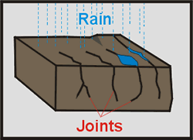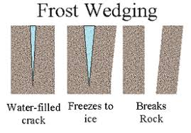

In your own words, explain how a pothole would from in the road.
______________________________________________________________________
______________________________________________________________________
______________________________________________________________________
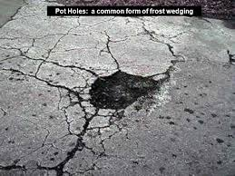
Where in the world are you likely to find potholes, and where are they unlikely? Why?
______________________________________________________________________
______________________________________________________________________
Chemical Weathering
Chemical weathering is the breakdown of rocks because they their ________________ composition has changed. Rocks will react with water, oxygen, carbon dioxide, and acid to dissolve minerals form new ___________________.
The ______________ composition of a rock will determine the effects that the chemical weathering will have on it. Some rocks are made of minerals that will break down, while others will not.
For example, limestone and _____________ are mostly made of a mineral called calcite. This mineral can completely ______________________ in acidic water. Thus, buildings and monuments made of limestone or marble will show signs of chemical weathering if they come into contact with an acid (like ________________________).
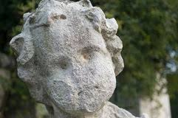
Biological Weathering
Living things can also break down rocks. In the same way that water can enter the rocks through small holes or joints, so can ___________________. When these roots grow, they exert __________________ on the rock around them, causing the gaps to widen or even crack.
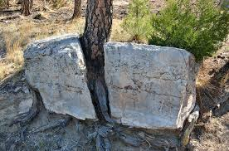
________________ can also contribute to weathering. Especially burrowing animals such as badgers and moles that can break up the rock underground or bring it to the surface, where it is _________________ to other weathering forces. Some animals directly burrow ____________ the rock, breaking it up.

As animals, humans also contribute to biological weathering. What are 3 different ways humans are contributing to biological weathering?
- ________________________________________________________________
- ________________________________________________________________
- ________________________________________________________________

Erosion
Erosion is the process of _______________ rocks from one location and ___________________ them at another location.
Erosion includes ___________________ (the breakdown of rocks) as well as the movement of those weathered rocks.
There are three major processes by which rocks are eroded: water, wind, and glaciers.

Rates of Weathering
There are four major factors that affect the rate at which rocks weather:
- Climate
- Rock type and composition
- Surface area
- Topography
Read the textbook pages 168-170, which describe the different factors that affect weathering, and answer the following questions.
- Where is chemical weathering most common and why?
____________________________________________________________________________________________________________________________________________

- Where is physical weathering most common, and why?
____________________________________________________________________________________________________________________________________________
- Many statues are built of marble for the rock’s beauty and ability to be carved. If the statue was designed for a park in Vancouver, would this be a good idea, and why?
__________________________________________________________________________________________________________________________________________________________________________________________________________________
- What rock would be better?
______________________________________________________________________

- Why would North Vancouver (mountainous) have more erosion then Richmond (flat)?
____________________________________________________________________________________________________________________________________________

Question 6 back side

- The paddock clam creates these small holes in the rock. How does this increase the rate of weathering?



